Centre for  Advanced computations in engineering science | 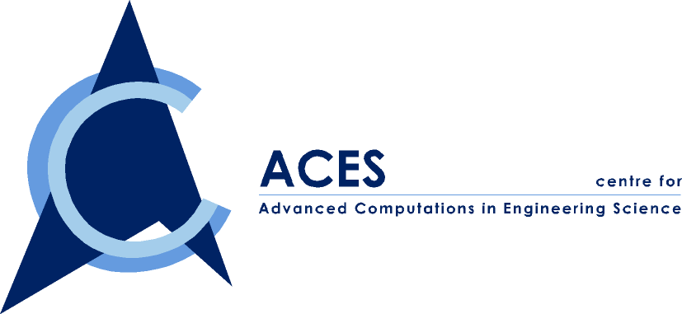

ACES Seminar: EFT

You are cordially invited to attend our ACES seminar series on

“A New Element Free Technique: the role of radial functions”

By Dr. Wang Jian Guo

Date: Friday, 12 November 1999
Time: 2:00-3:00 PM
Venue: ACES Conference Room, EA-04-27, NUS
Contact person: Dr. Wu ZP, Tel. 874 4795

ABSTRACT: Element-free technique is one of the advanced numerical techniques, which is based on only a set of scattered nodes without element mesh. It offers tremendous advantages over finite element methods (FEM) in solving complex problems in computational mechanics. There are two fundamental issues to be addressed in development of EFT. One is the approximation function over compact support (similar to shape function in FEM). Another is the numerical integration over the problem domain. In our research, we extended the concept of elements in FEM to compact support and derived the approximation function using various mathematical methods such as moving least square method (MLS), kernel function and Taylor series over the nodes. Each has certain advantages and disadvantages in the structural analysis for solid mechanics and foundation engineering.

This seminar presents a new element free technique using radial functions. The presentation includes three parts: First, an approximation for a point interpolation method (PIM) is presented using the exponential radial basis functions. It overcomes the singularity problem associated with polynomial bases. It has also simplest form of the partial derivatives. The interpolation functions are through scattered points and thus are of delta function property. Secondly, the validity of the proposed methods for interpolation over scattered points is studied for one- and two-dimensional functions. Finally, this interpolation method is applied to the weak form of solid mechanics problem and the accuracy and convergence ratio are also concluded through some practical examples.

ABOUT THE SPEAKER: Dr. Wang Jian Guo is currently a Senior Research Engineer at ACES. He obtained his PhD in Civil Engineering from Nagoya University, Japan and obtained his B.Eng and M.Eng in Tsinghua University, Beijing. Before joined ACES, he worked in National University of Singapore as a postdoctoral research fellow and in a private company for several years. He has both strong practical experience and academic background. His specialty is on constitutive laws, computational mechanics, visualization of numerical analysis and foundation engineering.

