Centre for  Advanced computations in engineering science | 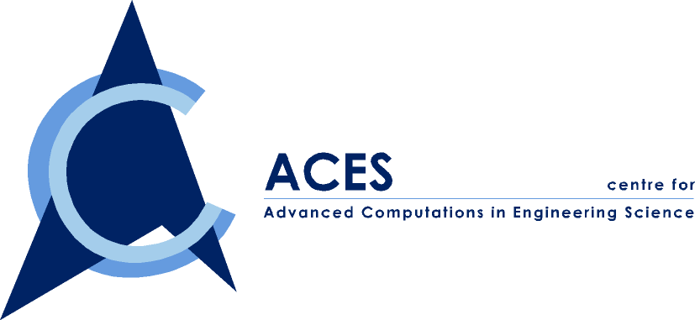

ACES Seminar: FEM

You are cordially invited to attend our ACES seminar series on

“Automatic Solid Decomposition & Reduction for Non-Manifold Geometric Model Generation”

By Mr. Chong Chiet Sing

Date: Friday, 28 January 2000
Time: 2:00-3:00 PM
Venue: ACES Conference Room, EA-04-27, NUS
Contact person: Dr. Wu ZP, Tel. 874 4795

ABSTRACT

Finite element modelling involves the processes of feature suppression, model idealization and meshing of the solid model. The bottleneck of the whole process is model idealization, which is the process of generating a geometric model into an analysis model of suitable quality and reduced size so that it may be analysed efficiently using FEA. In many finite element modelling problems such as shell analysis, structural considerations require simplification of the solid model. One generic technique for model idealisation is dimensional reduction. In dimensional reduction, the finite element model makes use of elements of reduced dimension, such as beams, plates and shells.

This seminar first discusses the motivation of this research and the current techniques that are available. This is followed by defining some operations and implementations using UFUNC (Unigraphics) that allow the user to reduce the dimensionality of geometric models automatically using a novel decomposition and reduction method.

ABOUT THE SPEAKER

Mr. Chong Chiet Sing obtained both his B.Eng and M.Eng in Mechanical Engineering from the National University of Singapore. He is currently a Research Engineer at IHPC.

