Centre for  Advanced computations in engineering science | 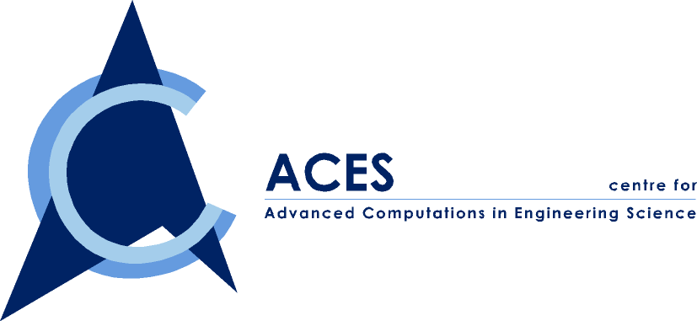
A Joint NUS-IHPC Research Centre

ACES Seminar

Jointly Organized by ACES and MPE

You are cordially invited to attend our seminar on

“Transduction Characteristics of Piezoelectric Transmitter and Receiver Elements in Structural Wave Acousto-Ultrasonic Applications”

By Dr. Martin Veidt

Date: Monday, 7 August 2000
Time: 10:00-11:00 AM
Venue: ACES Conference Room, EA-04-27, NUS
Contact person: Dr. Wu ZP, Tel. 874 4795

ABSTRACT

Structural wave non-destructive evaluation and health monitoring applications are becoming more and more popular, primarily because of the recent developments in understanding their complexity and potential. The design of optimised measurement systems relies on the ability to quantify the three fundamental processes of wave generation, propagation and detection.

In this seminar the concept of structural wave acousto-ultrasonics is briefly introduced and the complexity in characterising the behaviour of the individual system components identified. Afterwards, a new experimental-analytical methodology will be introduced which enables the determination of the electro-mechanical transduction characteristics of piezoelectric transducers adhesively bonded to isotropic or anisotropic plates. In addition, the results of investigations on the sensitivity of piezoceramic receiver elements for flexural wave detection will be presented.

ABOUT THE SPEAKER

Martin Veidt got his PhD in 1991 from the ETH in Zurich, Switzerland. After working for two years as a postdoctoral research fellow at Cornell, USA and for three years as a consulting engineer back in Switzerland, he joined the Department of Mechanical Engineering at the University of Queensland in late 1995. He is currently the Senior Lecturer. His major research interest lies in the area of ultrasonics, focusing on structural wave ultrasonics for non-destructive evaluation and health monitoring, phase-locked loop resonance methods and ultrasonic.

