Centre for  Advanced computations in engineering science | 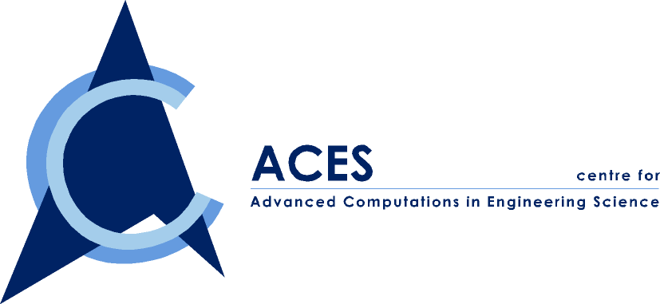
A Joint NUS-IHPC Research Centre

ACES Seminar

Jointly Organized by ACES and MPE

You are cordially invited to attend our ACES seminar series on

“Advanced Computations in Nano-structured
Magnetic Systems and Phase Transitions”

By Dr. Zhao Guoping

Date: Friday, 28 July 2000
Time: 2:00-3:30 PM
Venue: ACES Conference Room, EA-04-27, NUS
Contact person: Dr. Wu ZP, Tel. 874 4795

ABSTRACT

Nano-structured magnetic systems show some special features such as enhanced remanence and thermal activated magnetization reversal. The investigation of the underlying mechanism will help to improve the magnetic properties significantly. A new model has been proposed to explore the behavior of the nanostructured magnetic systems. It is found that the interesting phenomena in these systems are closely related to the magnetic moment distribution in the grain boundary, which is different from that in the grain center.

The magnetic moment in the grain boundary forms a transition region where the moment changes smoothly from one easy axis direction to the other easy axis direction in the remanent state (applied field H=0). The static behavior of the transition region is responsible for the observed remanence enhancement in nanostructured permanent magnets. The dynamic behavior of this transition region, the change of the transition region with the applied forces such as the applied magnetic field, explains the coercivity paradox well in these systems. Our work demonstrates that the coercivity of polycrystalline permanent magnets is limited by the nucleation of the domain walls in the grain boundaries assisted by the thermal activation. The energy barriers are found to be much smaller than that given by the Stoner-Wohlfarth model.

The relation between the nature of the molecular interactions and the resulting phase diagram is the central theme of equilibrium statistical mechanics. Recent computations have provided new insight into the structural and orientation behavior of strongly interacting dipolar hard and soft spheres but some ambiguity still exist. The interactions considered are an isotropic Lennard-Jones potential, which favors the condensation when the temperature decreases and an anisotropic dipole-dipole interaction potential, which favors the chain formation. The simulation shows that the phase diagram in these systems is quite complicate due to the competition of the interactions and sensitive to the boundary conditions. The sampling methods used in the simulation might also affect the results. More work is needed to clarify the ambiguities of the results.

ABOUT THE SPEAKER
Dr. Zhao Guoping is currently a research engineer at center for ACES. He obtained his B.S and M.Eng from University of Science and Technology of China and Southwestern Institute of Physics, respectively. He has completed his PhD study in Department of Physics, National University of Singapore. His research interests include the magnetic reversal in nano-structured systems, phase transitions and magnetic colloids.

