Centre for  Advanced computations in engineering science | 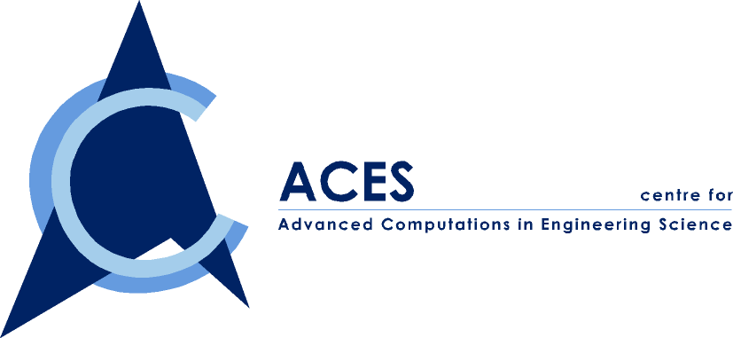
A Joint NUS-IHPC Research Centre

ACES Seminar

Jointly Organized by ACES and Dept. of Mechanical Eng.

You are cordially invited to attend our seminar on

“Energy Absorption and Energy Partitioning in
Structures and Materials under Impact or Collision”

By Professor Tongxi Yu
(Currently Visiting Research Professor at NUS)

Date: Friday, 2 Feb. 2001
Time: 2:00-3:00 PM
Venue: ACES Conference Room, EA-04-27, NUS
Fee: Free of charge
Contact person: Dr. Wu ZP, Tel. 874 4795

ABSTRACT

When an engineering structure is subjected to impact or intensive dynamic loading, it will usually undergo large plastic deformation, which dissipates the input kinetic energy. In some applications, the energy absorption capacity becomes the major concern in the design of structures or in the selection of materials. This seminar will first illustrate the fundamental principles in designing energy-absorbing structures and in selecting energy-absorbing materials, followed by a discussion on the differences in the performance of structures or materials under quasi-static and dynamic loading. To demonstrate how to assess the total energy absorption and the energy partitioning in structures with the help of various theoretical models, three typical examples will be presented, all being based on the recent studies in our group. These examples are: (1) a free-free beam subjected to a step-load or a projectile impact; (2) a translating free-free beam striking the tip of a cantilever beam, showing the dynamic interaction between two colliding deformable bodies; and (3) the large deformation process of a flat-topped conical shell, which serves as a cell in the grid-domed textile composite that we recently developed.

ABOUT THE SPEAKER

Professor Yu is professor in the Department of Mechanical Engineering, the Hong Kong University of Science and Technology. He got his first degree in Solid Mechanics from Peking University, Beijing, China in 1964 and continued a post-graduate study in the same university until 1968. After that, he worked as an engineer in machine-building industry in China for about 10 years. From 1980 to 1983, he conducted research on engineering plasticity in Cambridge University, UK, and got his PhD from Cambridge in 1983. In 1984-1991, he was professor in the Department of Mechanics, Peking University, China. Starting from 1991, he was reader in UMIST, UK, until joined HKUST in 1995. His research interests mainly focus on Impact Dynamics (e.g. structural response to impact and dynamic failure), Engineering Plasticity (e.g. mechanics of sheet metal forming and energy absorption) and Advanced Engineering Materials (e.g. textile composites and cellular materials). He has published 6 books and more than 260 academic papers, among which 200 papers were published in refereed journals. Presently, he is also a Fellow of HKIE and the President of the Hong Kong Society of Theoretical & Applied Mechanics. Owing to his outstanding contributions to applied mechanics, Cambridge University awarded him ScD (Doctor of Science) in 1995.

