  Department of Mechanical Engineering  National University of Singapore | Centre for Advanced Computations in Engineering Science  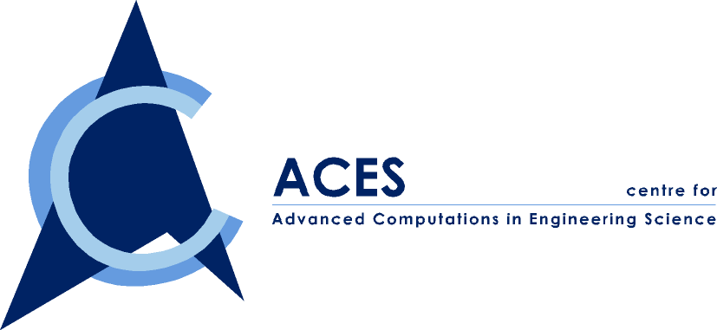  A Joint NUS-IHPC Research Centre

Dept. of Mechanical Eng. – ACES/IHPC Workshop on

Numerical and Analytical Mechanics

to be held on 21st Feb. 2001
At Block EA-02-11 (executive seminar room)

The Department of Mechanical Engineering, Centre for Advanced Computations in Engineering Science and the Institute of High Performance Computing are jointly organizing a workshop on Tuesday, 21st February 2001 on Numerical and Analytical Mechanics. This workshop is organized in conjunction with the visit of Prof. Yu Tongxi from Hong Kong University of Science and Technology and Prof. Wang Chang Yi from Michigan State University. The topics include, but not confined to, Membrane vibration- some semi- analytic methods for the Helmholtz equation, Analysis and numerical simulation of a virtual internal bond model for fracture dynamics, Dynamic Failure of Structures under Impact, Application of FEM in dynamic analysis of chain-sprocket system. The aim of this workshop is to foster research interaction among local research institute, industry and international universities.

Objectives:

The objective of this workshop is to bring together researchers in numerical and analytical mechanics in engineering and science from the academia and the industry to discuss the recent development in computational aspects of numerical and analytical mechanics.

Invited Speakers:

Professor Wang Chang Yi (Michigan State University)
Professor Yu Tongxi (Hong Kong Unviersity of Science and Technology)
Assis/Professor Lin Ping (National University of Singapore)
Dr. Wang Yu Yong (Institute of High Performance Computing)

Registration Fee:

There is no registration fee.

Submission of papers and representations:

Papers and representations are warmly welcome. Duration for each topic is 45 minutes, including questions and answers session.

For all the submissions, an abstract shall be submitted first before 10th Feb 2001. The follow preparation shall be finalized not later than 16th Feb. 2001. It would be appreciated that the outlines or the paper of the each topic is submitted before 16th Feb. 2001. It is for the distribution to the audience on the day of the workshop.

The final copy of the papers could be submitted after the workshop for publication. Maximum number of pages is limited to be 20 A4 pages.

The format shall be referred to the file of “paper format” for the details.

Contact Person: Dr. Wu Zhengping,
Tel. 8744795 email acewuzp@nus.edu.sg

Proceeding of the Workshop

Papers of the presented topics will be published in a form of proceeding book by the Centre for ACES and distributed for academic exchange purposes. The papers will also be posted on the website of ACES, which allows to be referred and cited by the interested researchers.

About the Invited Speakers

Professor Wang Chang Yi

Prof. C.Y. Wang obtained his B.S. from Taiwan University in 1960 and his Ph.D. from MIT in 1966. He did postdoctoral work at Caltech and Einstein College of Medicine. He is now professor of Mathematics, Mechanical Engineering and Physiology at Michigan State University. Prof. Wang has about 300 refereed publications. His interests include the mechanics of fluids, solids and theoretical biology.

Professor Yu Tongxi

Professor Yu is professor in the Department of Mechanical Engineering, the Hong Kong University of Science and Technology. He got his first degree in Solid Mechanics from Peking University, Beijing, China in 1964 and continued a post-graduate study in the same university until 1968. After that, he worked as an engineer in machine-building industry in China for about 10 years. From 1980 to 1983, he conducted research on engineering plasticity in Cambridge University, UK, and got his PhD from Cambridge in 1983. In 1984-1991, he was professor in the Department of Mechanics, Peking University, China. Starting from 1991, he was reader in UMIST, UK, until joined HKUST in 1995. His research interests mainly focus on Impact Dynamics (e.g. structural response to impact and dynamic failure), Engineering Plasticity (e.g. mechanics of sheet metal forming and energy absorption) and Advanced Engineering Materials (e.g. textile composites and cellular materials). He has published 6 books and more than 260 academic papers, among which 200 papers were published in refereed journals. Presently, he is also a Fellow of HKIE and the President of the Hong Kong Society of Theoretical & Applied Mechanics. Owing to his outstanding contributions to applied mechanics, Cambridge University awarded him ScD (Doctor of Science) in 1995.

Assis/Professor Lin Ping

Dr. Lin received his PhD in Applied Mathematics in December, 1995 from the University of British Columbia, Canada. He was then a NSERC postdoctoral fellow at Division of Mechanics and Computation (formally Division of Applied Mechanics) in Stanford University from 1996 to 1998 and also a research associate at the Department of Computer Science in Rensselaer Polytechnic Institute in 1998. He is currently an assistant professor at the Department of Mathematics, NUS. The main emphasis in his research is in applied mathematics and in the areas of numerical analysis, scientific computing and computational mechanics. His work has primarily been concerned with the numerical solution of various ordinary and partial differential equations, and of problems with multi-scales (singular perturbation). Applications include various engineering problems such as fluid dynamics (viscous incompressible flow), miscible displacement in porous media, nonlinear wave equations for atomistic and continuum models in material fracture, constrained mechanical systems in robotics and vehicle simulation, combustion and a chemical reaction model, etc. His paper entitled “A sequential regularization method for incompressible Navier-Stokes equations” received the American SIAM (Society of Industrial and Applied Math) best PhD paper prize.

Dr. Wang Yu-yong

Wang Yu Yong obtained his BEng. and MEng. in 1986 and 1988, respectively,from Department of Engineering Mechanics, Tsinghua University, P. R. China.He worked as a Lecturer in Tsinghua University for five years during 1989 to 1994. After he complited his Ph.D. study at Department of Mechanical Engineering of Natinal University of Singapore in 1997, he joinded IHPC as a Research Engineer. Now he works as a Principal Research Engineer in IHPC.His R&D activities include static and dynamic analysis of engineeringn stuctures and consumer products, Numerical simulations on impact and drop test.

