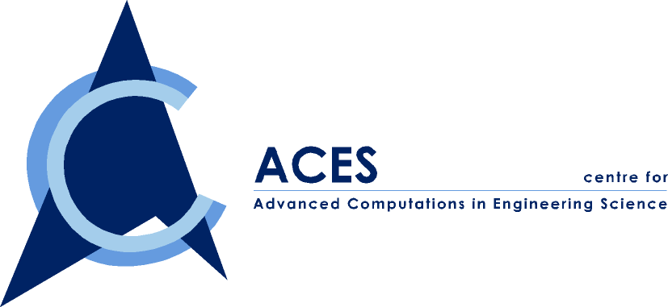
A Joint NUS-IHPC Research Centre

ACES Seminar

You are cordially invited to attend our ACES seminar series on

“Research and Development of Advanced Composite Materials for Aerospace Industry in China”
By Prof. Du Shanyi

Date: 05 Dec 2002
Time: 10:00 AM – 12:00 PM

Venue: E1A-03-14, NUS
Contact person: Dr. Han Xu Tel : 6874 4795
Email : acehanxu@nus.edu.sg

ABSTRACT

In this review, the following topics will be introduced:
1. The development of Aerospace Industry in China;
2. The importance of composite materials for Space Engineering – Raising quality, Reducing cost, Raising structural Efficiency and Reliability;
3. New mechanics Problems of composite material structure working in the case of some very special conditions;
4. The application of advanced composite materials for Aerospace Industry in China;
5. The Research and Development of Advanced composite materials for Aerospace Industry in China.

Prof. Du ShanYi is currently an academician of Chinese Academy of Engineering, the vice president of Chinese society of theoretical and applied mechanics, and the president of Chinese society for composite materials. His research interests are mainly on composite materials, solid mechanics, smart materials and structures and reliability of aircraft structures. He has published 3 books and more than hundred academic papers. Presently, he is the director of the research centre for composites, Harbin Institute of Technology, China.

